Mpox situation report till 31 August 2023

2023-10-16

Table of Contents

Summary 2

1. Person 3

2. Place 6

3. Time 7

# Summary

As of 2023-08-31, a total of **427** suspect monkeypox cases were reported from **5**. Out of *427* reported cases, **261 (61.1%)** confirmed mpox cases by PCR test.

***From positive cases***, 6 (2.3%) fatal cases were recorded. Males represented 209 (80.1%) of total positive cases. The median(IQR) age of positive cases was 38 (31, 62). There are 149 and 112 positive cases in 2022 and 2023, respectively.

# 1. Person

**Table 1: Mpox confirmed cases by age group and sex, till 31 July 2023**

| **Characteristic** | **female**, N = 341 | **male**, N = 2091 |
| --- | --- | --- |
| Age group |  |  |
| 0-9 | 0 (0%) | 3 (1.4%) |
| 10-19 | 0 (0%) | 2 (1.0%) |
| 20-24 | 0 (0%) | 10 (4.8%) |
| 25-29 | 6 (18%) | 24 (11%) |
| 30-34 | 8 (24%) | 44 (21%) |
| 35-39 | 5 (15%) | 30 (14%) |
| 40-44 | 2 (5.9%) | 25 (12%) |
| 45-54 | 2 (5.9%) | 20 (9.6%) |
| 55-64 | 0 (0%) | 4 (1.9%) |
| 65+ | 11 (32%) | 47 (22%) |
| 1n (%) | | |

***Figure(1): Age-sex pyramid of reported Mpox cases till 31 August 2023***

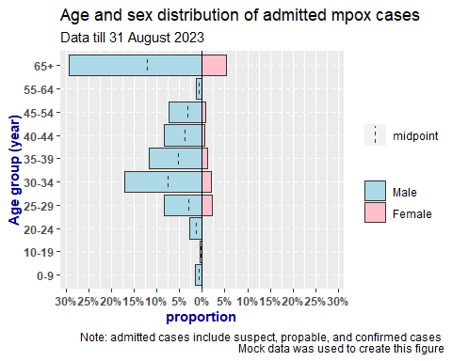

***Figure(2): Distribution of confirmed Mpox cases’ outcome by symptom presence***

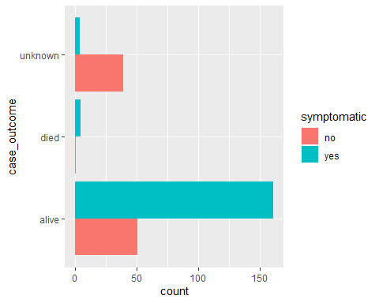

# 2. Place

**Table 2: Confirmed Mpox cases by country**  
*Date as of 31 August 2023*

| **Country** | **Total cases** | **Total death** | **Cases in July 2023** | **Cases in August 2023** | **Monthly change %** | **Most recent admission date** |
| --- | --- | --- | --- | --- | --- | --- |
| **Country A** | 29 | 1 | 2 | 1 | -50% | 2023-08-16 |
| **Country B** | 67 | 2 | 3 | 6 | 100% | 2023-08-23 |
| **Country C** | 35 | 1 | 2 | 3 | 50% | 2023-08-31 |
| **Country D** | 63 | 0 | 4 | 6 | 50% | 2023-08-22 |
| **Country E** | 67 | 2 | 5 | 4 | -20% | 2023-08-30 |

# 3. Time

***Figure(3): Weekly distribution of confirmed mpox cases by reporting country and date of admission***  
Date till 2023-08-31

